**Sicily cultural**

7 nights / 8 days

**PROGRAM**

**1st day - Arrival to Palermo**

Landing to Palermo airport and private transfer to the hotel.

**Overnight in Palermo**

**2nd day – Full Day Monreale + Palermo**

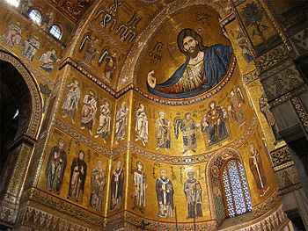Departure to Monreale for a visit to the wonderful Cathedral with its Byzantine mosaics and the adjoining Cloister recognized as the masterpiece of medieval art.

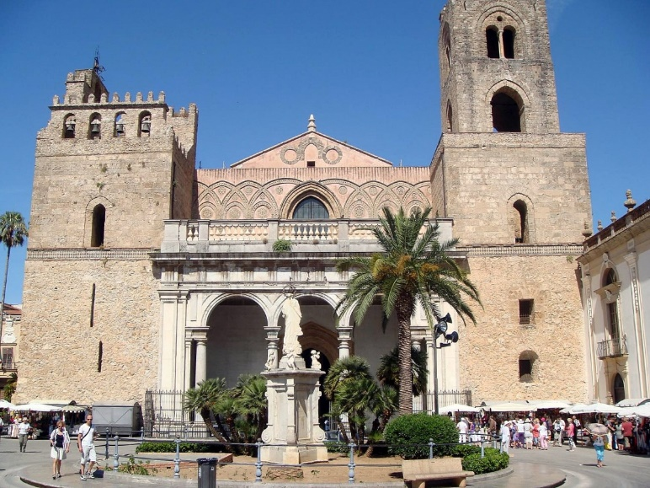

At the end of the visit, transfer to Palermo to continue the tour, visiting the Palazzo dei Normanni and the exterior of the most important buildings located along the main street (Cathedral, Martorana Church, Fontana delle Vergogne).

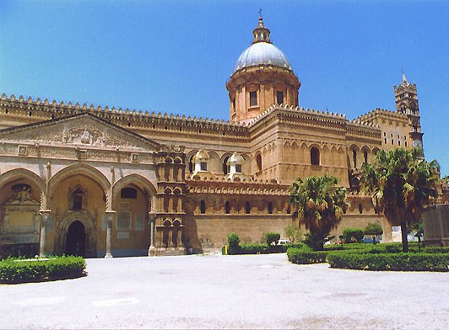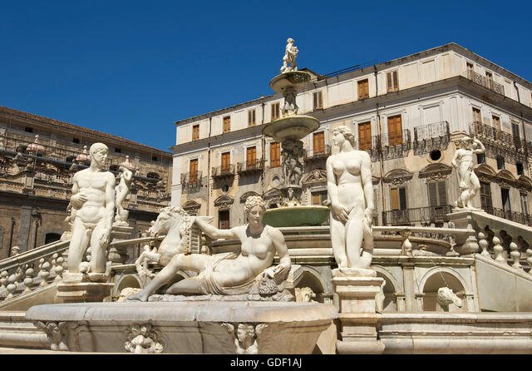

Lunch will be organized during the tour in a typical trattoria. At the end of the tour, transfer back to the hotel

**Overnight in Palermo**

**3rd day - Full Day Erice and Segesta**

Departure for a full day excursion to Erice and Segesta.

Erice is a very nice town located on high ground overlooking the northern coast of western Sicily.

Ancient Eryce was a prosperous Elimi city, Eryx, famous for its temple to a fertility goddess Venus. With its delightful medieval ambience and splendid location, Erice is an interesting town popular with travellers. There are two castles, Pepoli Castle, with foundations dating from Saracen times, and Venus Castle, dating from the Norman era but built on ruins of the ancient Temple of Venus. Surrounded by a lush park, the hilltop castles alone are worth a stop in Erice, which offers charming old stone streets and medieval churches.

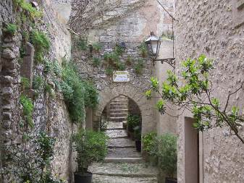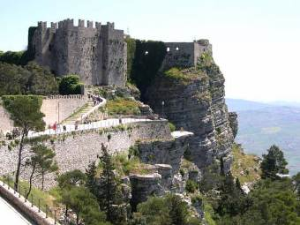

Lunch will be arranged in a local restaurant with typical dish of the area.

After lunch visit at the archaeological site of Segesta: it is an abandoned ancient city located at about 74 kilometres southwest of Palermo.

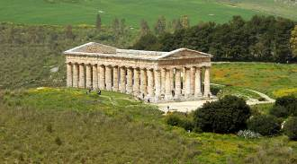

This large archaeological zone, with its magnificent [Doric temple](javascript:openWin('greek.htm');), ranks as one of the best-preserved Greek architectural sites to be found any place.

There are virtually no modern-day structures to disturb the setting of the temple. You can really enjoy the splendour of the structure and the tranquillity of the setting. At Segesta, you can easily imagine what it was like to live in Sicily in ancient times.

After the visit, return to the hotel.

**Overnight in Palermo**

**4th day – Agrigento, Piazza Armerina, Taormina**

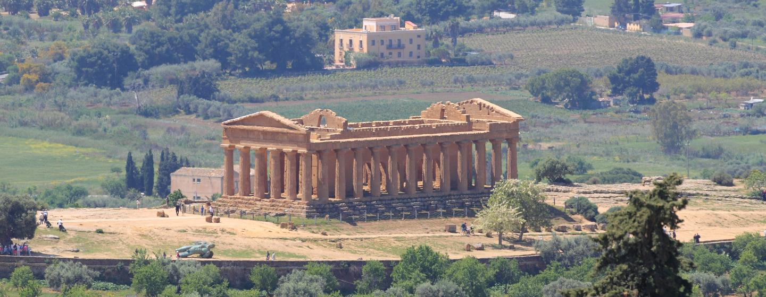Check out and departure to Agrigento, upon arrival, meet with the local guide and walking visit at the Temple valley.

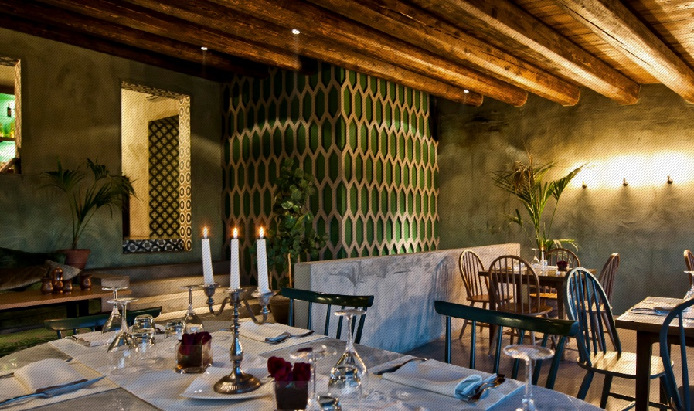Valleys, hills, monuments and temples, old and ancient, almost all dating back to the time when all civilization finest resided in the Mediterranean, are the traits that have made a city of Agrigento memory. The imposing Doric temples, the agora, the pagan and Christian necropolis and the network of underground aqueducts, are the wealth of a site that covers about 1300 hectares and tells a long history that began in the sixth century. B.C. with the founding of the ancient Greek colony of Akragas and which are now the archaeological heritage of humanity, included in the list of UNESCO since 1997.

The Valley of the Temples of Agrigento is still today the most sublime evidence of the Greek civilization in Sicily.

Lunch will be arranged in a restaurant of good level, overlooking the temple valley

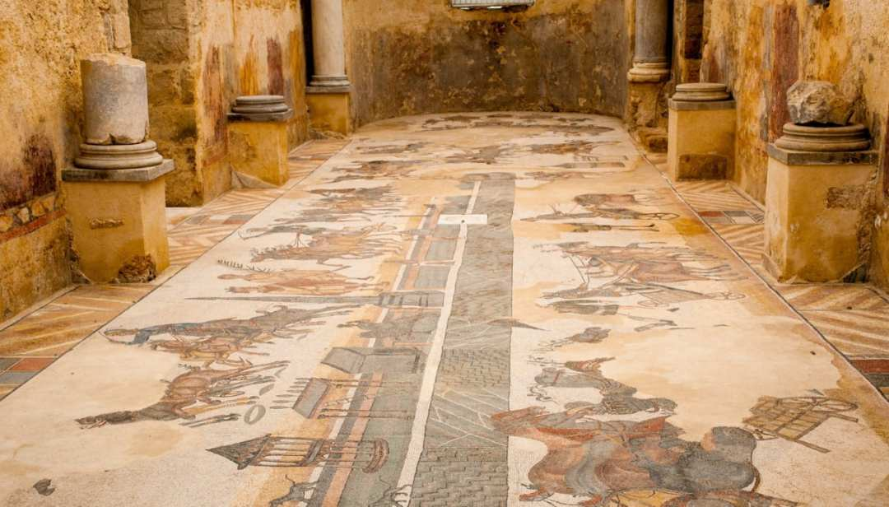The excursion continues towards Piazza Armerina for visit the Villa Romana del Casale. It is a large and elaborate [Roman villa](https://en.wikipedia.org/wiki/Roman_villa). Excavations have revealed one of the richest, largest, and varied collections of [Roman mosaics](https://en.wikipedia.org/wiki/Roman_mosaic) in the world, for which the site has been designated as a [UNESCO](https://en.wikipedia.org/wiki/UNESCO) [World Heritage Site](https://en.wikipedia.org/wiki/World_Heritage_Site). The villa and artwork contained within date to the early 4th century AD.

The mosaic cover 3,500 sq metres floor and are almost unique in their excellent state of preservation due to the landslide and floods that covered the ruins.

At the end of the visit, transfer to Taormina.

Arrival to the hotel late in the afternoon.

**Overnight in Taormina**

**5th day – FD Taormina - Etna South – Taormina**

Departure to Mount Etna, driving along highway and then mountain road through the villages, crops of vineyards, olive trees, fruit trees and, from 1000 m. onwards, chestnut and pine forests, you reaches an altitude of 1900 mt. (Rifugio Sapienza) , where the road ends at a large parking lot. Here you can have a look of the Crateri Silvestri and is possible a short hiking to walk around the 2 Craters. Highly recommended closed shoes, long pants, and jacket. All the landscape is lunar because it is already one kingdom of lava.

From here is possible to join an optional extension by private cable car that leads to an altitude of 2500 mt + Unimog and mountain guide, to reach altitude of 2900 mt.

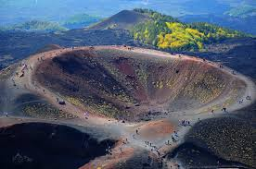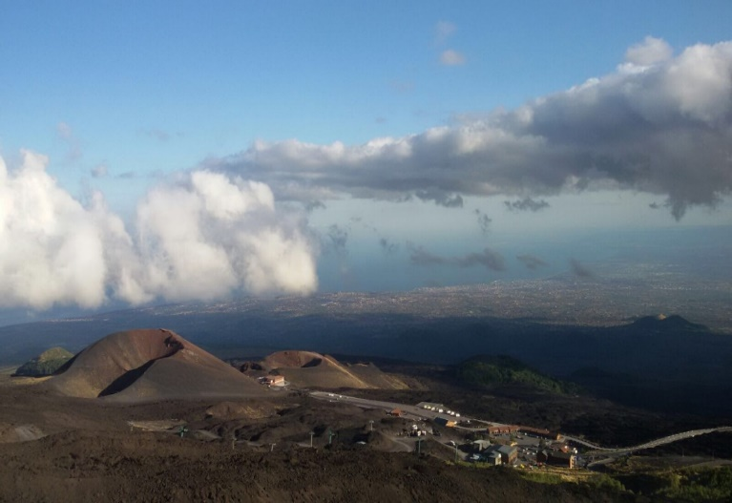Tickets to be paid on the spot (cost for 2022 = € 68,00 p.p.) . From up, you can admire the panorama overlooking half Sicily coast and the slopes of the main craters. About 40 minutes walking with multilingual explanation by mountain guide.

Lunch will be arranged in the nice private winery “Barone Villagrande” in order to taste the Etna wine and visit one of the most ancient wineries on Mount Etna. Menu of the day with selection of 5 wines paired with dishes prepared with fresh ingredients.

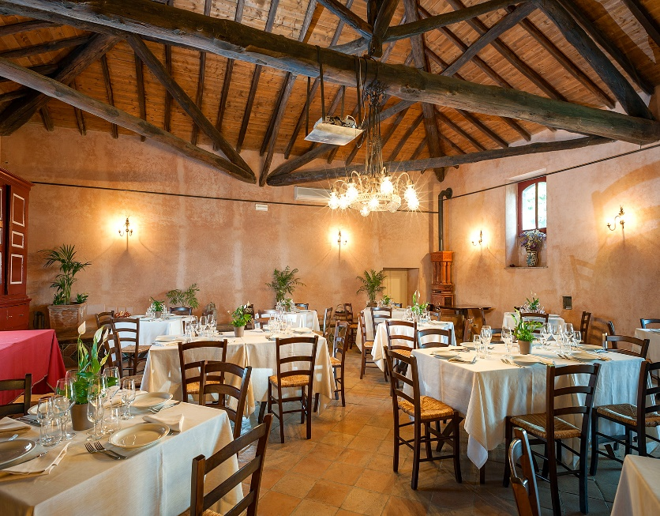

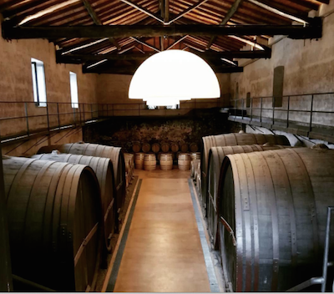

At the end of the wine tasting, transfer to the hotel.

**Overnight in Taormina**

**6th day – Half Day Taormina + afternoon free**

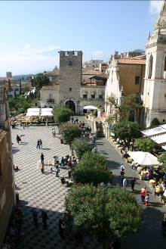Taormina city tour: it has intricated medieval streets and narrow alleys, each with its own secrets, excellent restaurants, cafes and ice-cream parlours. Taormina is beautiful by day, but in the evening its atmosphere is simply enchanting, whether you walk along the illuminated streets or enjoy the view of the coast. Between its eternal stone walls, ancient Taormina has fascinating archaeological monuments and medieval houses.

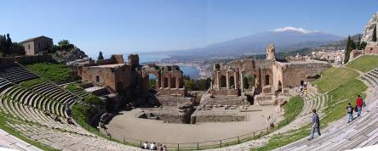

A magnificent view of the sea completes the picture. The most famous is the view of the Greco-Roman amphitheatre, one of the largest in Sicily, with Etna and the sea in the background.

**Overnight in Taormina**

**7th day – Full Day Taormina - Siracusa & Noto - Taormina**

Departure to Siracusa. Upon arrival visit the archaeological area. Visit the Greek Theatre and Latomie del Paradiso with its famous Ear of Dionysus (a cave with the shape of a tympanum).

Then, transfer to the city centre of Ortigia Island, primitive cradle of the Greek civilization in Sicily.

Lunch in a trattoria

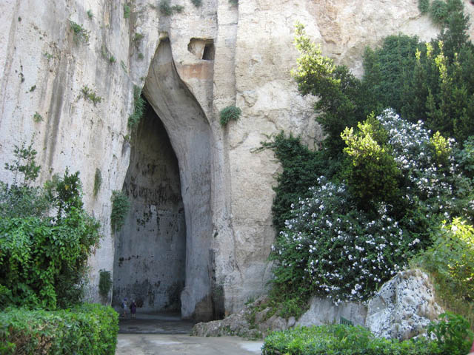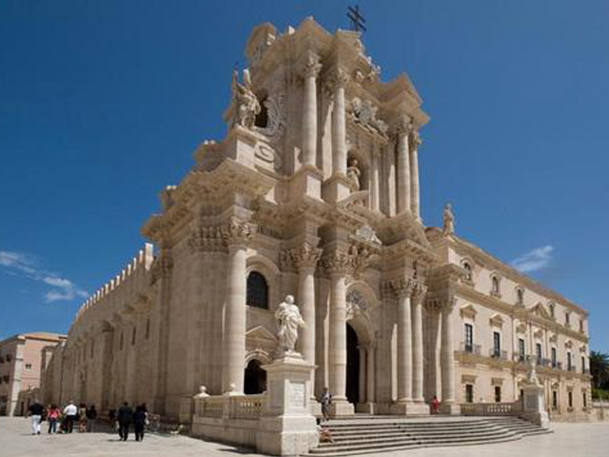

Afterwards the excursion continues towards Noto the most famous baroque town in Sicily. The beauty of Noto’s buildings owes much to the artistic gifts of the local architects and to the skill of local craftsmen (baroque façades).

For its beauty, Noto was declared “World Heritage Site”.

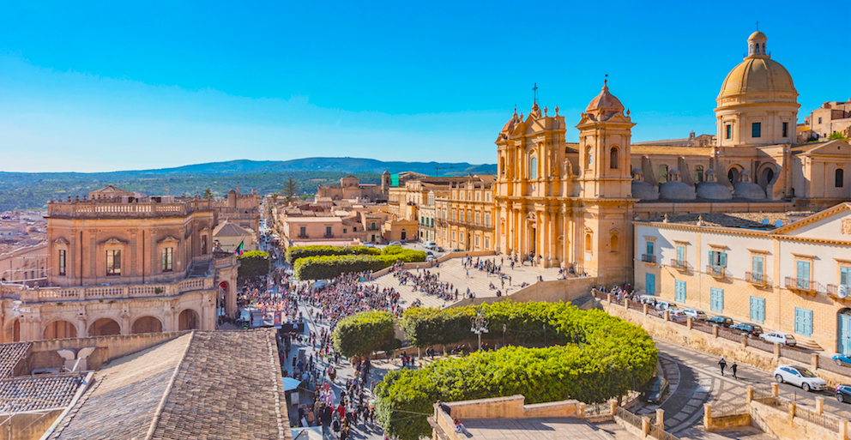

At the end of the tour, transfer to the hotel.

**Overnight in Taormina**

**8th day - Departure from Catania airport**

Transfer to Catania airport for departure.