**Sicily “Soft adventure”**

7 nights / 8days

**PROGRAM**

**1st day - Arrival to Palermo**

Landing to Palermo airport and private transfer to the hotel.

**Overnight in Palermo**

.

**2nd day – Monreale + Palermo with street food experience**

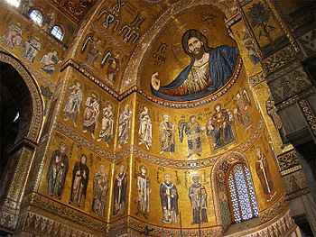Departure to Monreale for a visit to the wonderful Cathedral with its Byzantine mosaics and the adjoining Cloister recognized as the masterpiece of medieval art.

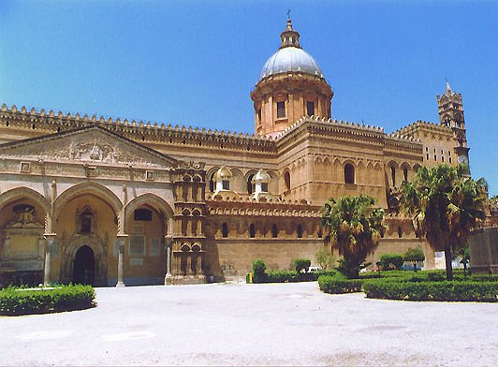

At the end of the visit, transfer to Palermo to continue the tour, visiting the Palazzo dei Normanni and the exterior of the most important buildings located along the main street (Cathedral, Martorana Church, Fontana delle Vergogne).

Lunch will be organized as per a street food tasting.

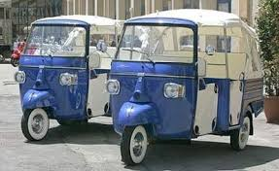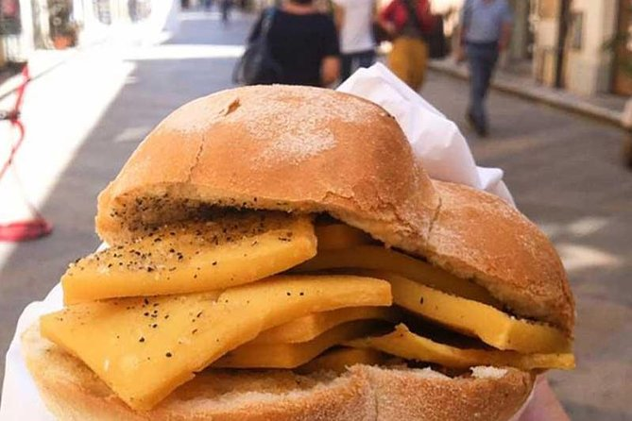After lunch, there will be a funny 3 wheel motorbike tour through the narrow streets of the Arab Quarter (duration about 1 hour, capacity : 3 pax max).

At the end of the tour, transfer back to the hotel

**Overnight in Palermo**

**3rd day - Cefalù & Wine tasting on Madonie mountains**

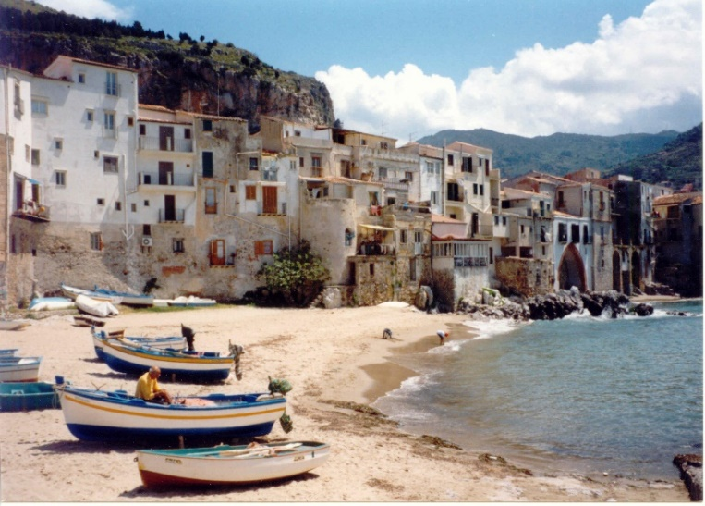Departure to Cefalù : the town was an ancient fishing village, today a famous tourist center. Set in the medieval district, Cefalù's great tourist attraction is the town's Duomo, a handsome and imposing two-towered Norman cathedral. Begun in 1131, this mighty church dominates the rooftops of the *centro storico*. The building's interior is decorated with lovely mosaics created by twelfth-century Byzantine artists: a large Christ Pantocrator on a gold background dominating the apse, above the Madonna, archangels, and Apostles. These gleaming mosaics are one of Sicily's greatest sights.

Impressive the sandy beach stretching alongside the town with houses built just on the sand and rocks.

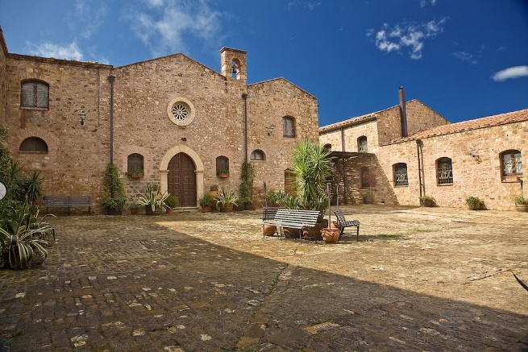At very few minutes far from Cefalù exists a magic place, the “Abbazia Sant’Anastasia”. Literally a piece of heaven, this old abbey is now famous all over the world because of its gold-medal-awarded winery company. There you will taste some of their selected wines and typical appetizers, all with an unforgettable visit to their wine cellar where you will enjoy the smell of their handcrafted oak barrels manufactured in the department of Allier. Definitely a must for the guest that visits this side of Sicily. The Madonie Mountains are scattered with picturesque hilltop towns.

On of the nicer village of the area is Castelbuono. Nice is a walking in the idyllic town centre famous also for the majestic castle “Ventimiglia” with a small chapel dedicated to Sant’Anna.

Return to the hotel in the afternoon

**Overnight in Palermo**

**4th day – Caccamo & Corleone**

Departure to Caccamo and visit the castle and the cathedral.

Caccamo is truly a gem that very few people get the chance to see. Not many tourists wander about the streets here and those who do are likely visiting a relative.

Caccamo is a small medieval village with about 8,000 residents that rises up on a rock promontory. At  500 meters above sea level, in order to reach it, you’ll need to drive along several hairpin turns, the road snakes up the hill making it perfect for car races.

As soon as you reach the village, you can easily reach the [feudal castle](https://www.google.it/maps/dir/Castello+di+Caccamo,+Corso+Umberto+I,+Caccamo,+PA/@37.9320082,13.5900017,12z/data=!4m9!4m8!1m0!1m5!1m1!1s0x1317538d5c55f9f5:0xd03ca4de2fdb39f4!2m2!1d13.6600426!2d37.9318936!3e0), the largest in Sicily and the symbol of Caccamo. The castle is in a strategic position because it overlooks the whole valley, and its majesty represents the power and richness of the lords of the past.

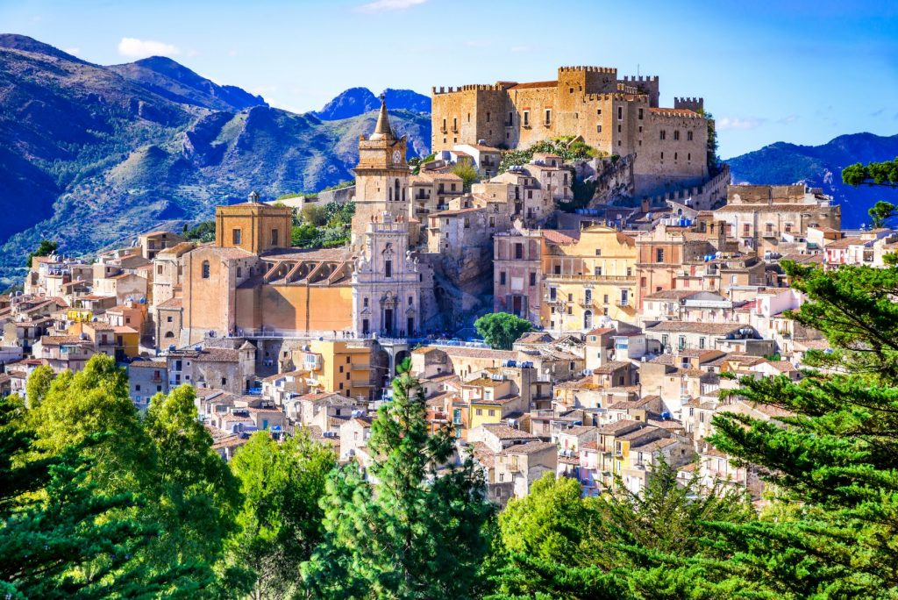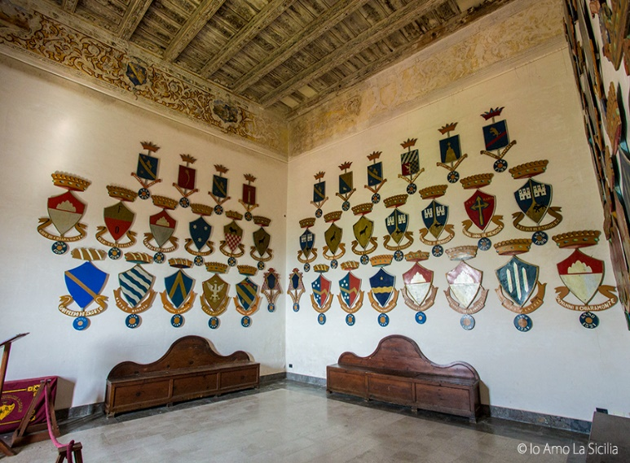So many legends have been told about this castle, making it more intriguing. Among the most famous is the story of a Lord’s daughter who had fallen in love with a soldier. When the Lord found out about their romance, he sentenced the soldier to death and locked his daughter in a cloister where she supposedly died of a broken heart. Legend has it that the daughter’s soul still wanders the castle during the full moon.

Another attraction is an experience to an **Old Butchery that produce** famous sausages ranging from ingredients like walnuts, pistachios, honey from Sicilian black bees. Here you can assist a demo of sausage making and learn how to do it ! Time free for lunch.

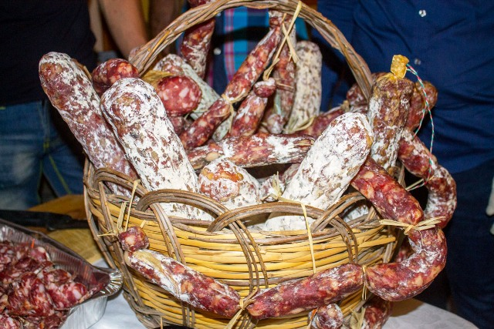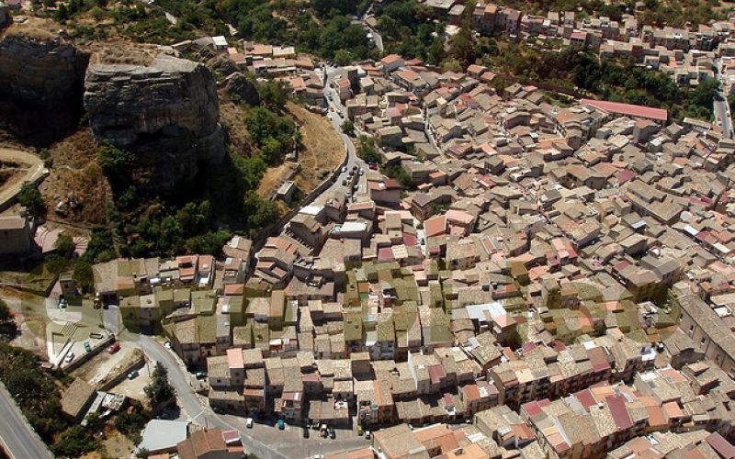

The excursion continues to Corleone. The infamous village in the heart of Mafia territory and of course, made a household word through the Francis Ford Coppola masterpiece, The Godfather.

Much of Corleone’s (less than angelic) fame comes from the Godfather movie. The later Marlon Brando assumed the role of Don Vito Corleone, a Mafia boss who had come to America from his native Sicily where he found himself immersed in power struggles with rival mafia families.

An international success, the film brought unexpected attention to Corleone and the locals are often thought to be Mafiosi although many of them have never stolen so much as a piece of candy.

Before the book and the movie, Corleone’s criminal reputation had already begun to spread. The idea that all the Corleonesi (inhabitants of Corleone), were Mafiosi came from the Corleone-born capi (bosses). Many of these ran the Cosa Nostra over the past fifty years. Two examples might be the murderous Salvatore “Totò” Riina and Bernardo Provenzano. Walking tour in the village. It’s just a small centre with some old and new houses.

Return to the hotel in the afternoon

**Overnight in Palermo**

**5th day - Erice and the salt road – Mazara del Vallo**

Check out and departure to Erice.

Erice is a very nice town located on high ground overlooking the northern coast of western Sicily.

The city has medieval origin and walking in the narrow street is a pleasant experience. medieval churches.

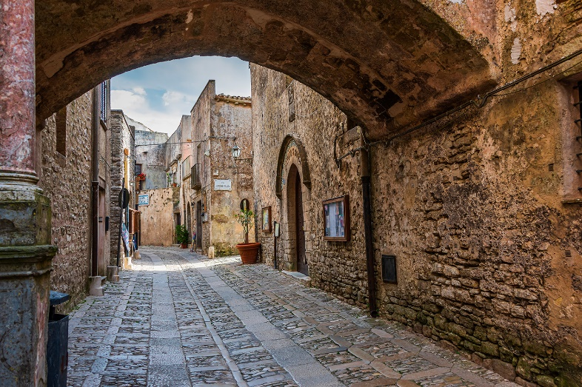Lunch in a restaurant of the centre.

Afterwards, the excursion continues through an interesting trip along the coastal road that goes to Mazara del Vallo and flanked by Saline and old windmills where is possible to admire the wide salt lakes.

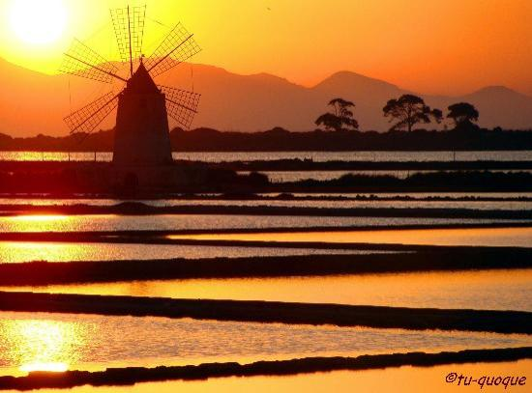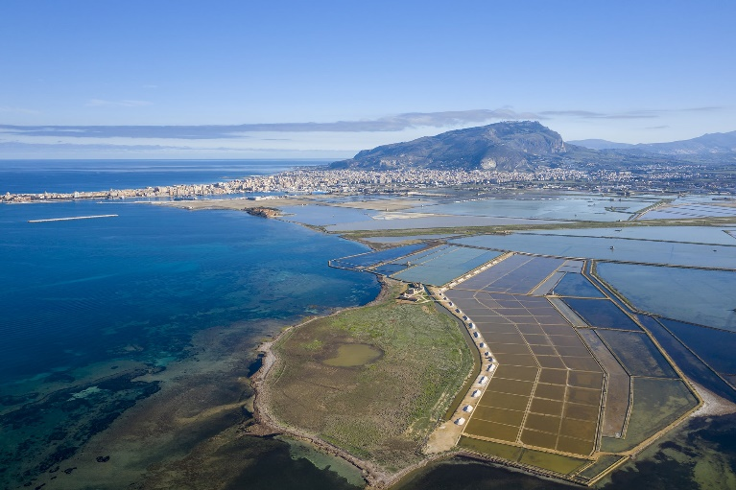Amazing are the sunsets from this area

Arrival to the hotel in the evening

**Overnight in Mazara del Vallo**

**6th day – Mazara del vallo - Agrigento - Taormina**

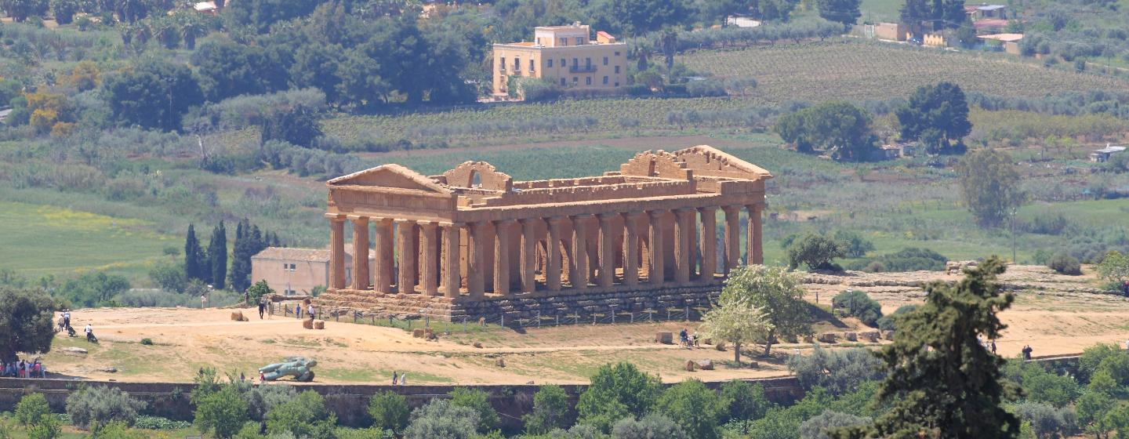Departure to Agrigento, upon arrival, meet with the local guide and walking visit at the Temple valley.

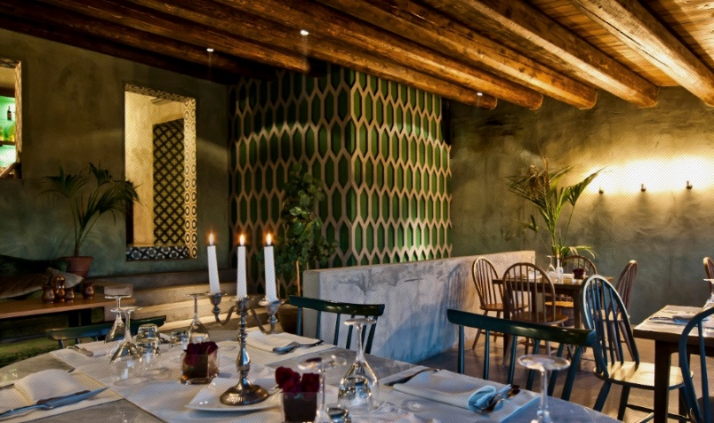Valleys, hills, monuments, and temples, old and ancient, almost all dating back to the time when all civilization finest resided in the Mediterranean, are the traits that have made a city of Agrigento memory. The imposing Doric temples, the agora, the pagan and Christian necropolis and the network of underground aqueducts, are the wealth of a site that covers about 1300 hectares and tells a long history that began in the sixth century. B.C. with the founding of the ancient Greek colony of Akragas and which are now the archaeological heritage of humanity, included in the list of UNESCO since 1997.

The Valley of the Temples of Agrigento is still today the most sublime evidence of the Greek civilization in Sicily.

Lunch will be arranged in a restaurant of good level, overlooking the temple valley.

After lunch, transfer to Taormina

**Overnight in Taormina**

**7th day – Taormina – Etna South - Taormina**

Departure for an amazing excursion to southern Etna to admire the majesty of the volcano. You will take the motorway up Giarre (about 20 km), then mountain road through the Etna villages, vineyards, olive groves, fruit trees and 1000 mt. then, chestnuts and pine forests.

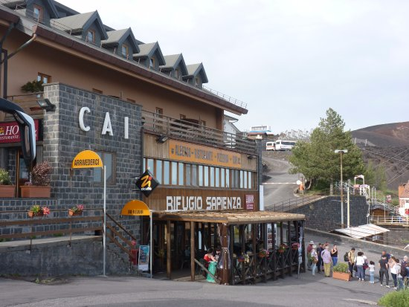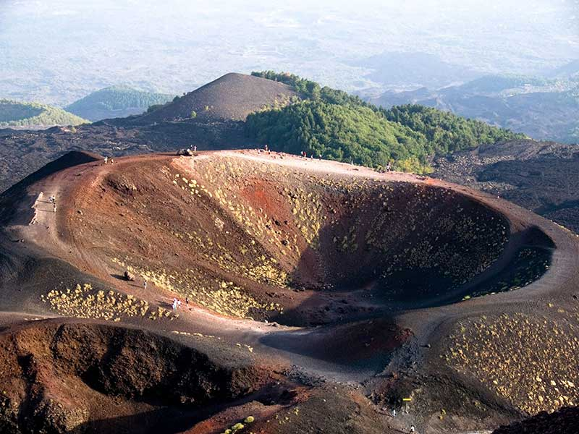You’ll reach 1900 mt., where the road ends in a large car park and where Rifugio Sapienza, the starting point of the cable car and jeeps, the only means allowed to continue beyond 1900mt.

The landscape is lunar, characterized by the 2 Silvestri Craters: their formation dates to the eruption of 1892. Today, they are among the most famous cones of the entire volcanic building because of one of the most popular tourist areas of Etna.

From Rifugio sapienza, departure by cable-car and 4x4 minibus (max. 28 pax per vehicle) to reach the altitude of 2900mt, the highest point reachable today (Etna's total height is 3.300mt). Transportation is public, so it is possible to add other passengers outside the group.

Jeeps are driven by authorized alpine guides. The extension takes about 2h, 30. Upon arrival, walking tour of about 40 minutes, assisted by multilingual Alpine guides.

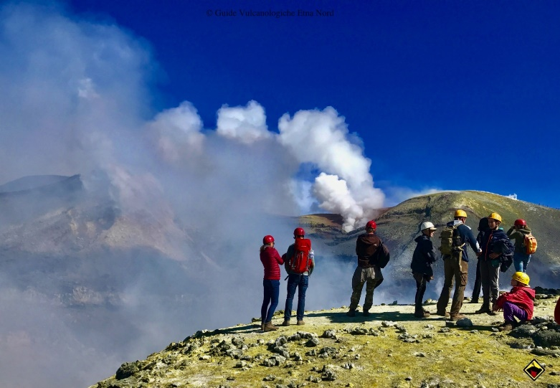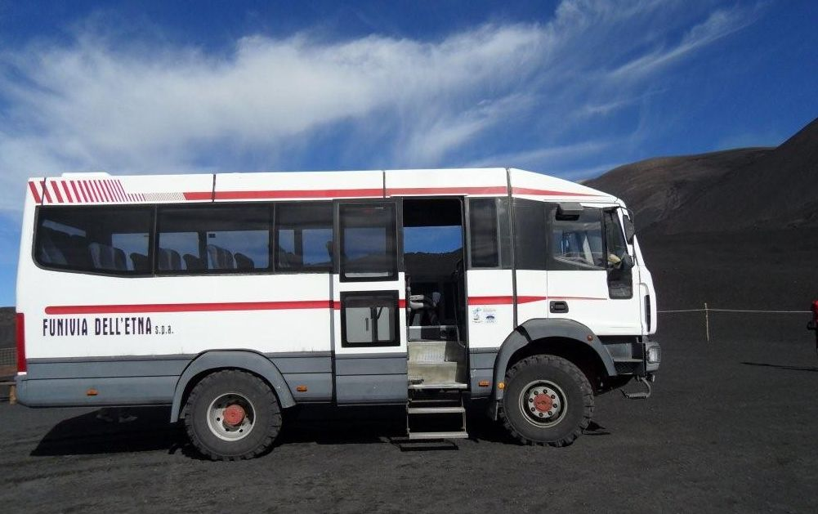

Wine tasting lunch in a winery located on the slopes of Mount Etna.

After lunch, transfer to Taormina

Upon arrival, walking visit: the village has intricated medieval streets and narrow alleys, each with its own secrets, excellent restaurants, cafes and ice-cream parlours. A magnificent view of the sea completes the picture.

The most famous is the view of the Greco-Roman amphitheatre, one of the largest in Sicily, with Etna and the sea in the background.

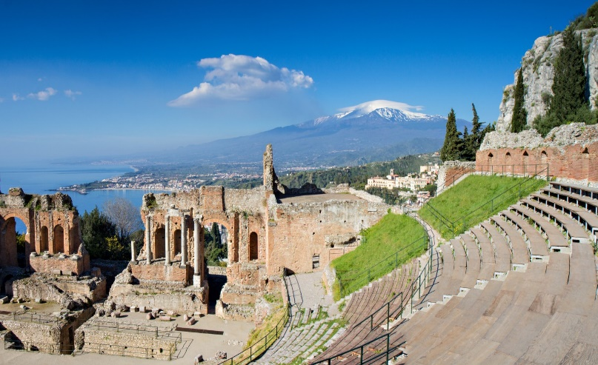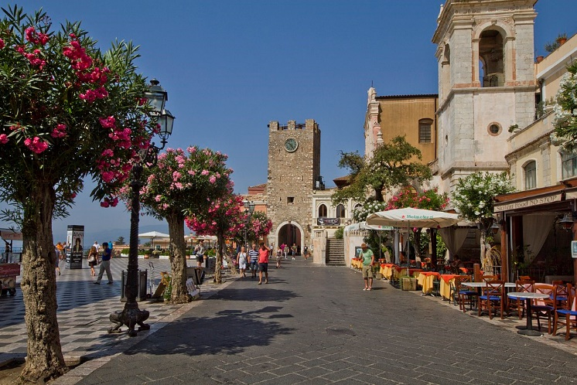

**Overnight in Taormina**

**11th day - Departure from Catania airport**

Transfer to Catania airport for departure.