**Sicily “Food experience”**

7 nights / 8days

**PROGRAM**

**1st day - Arrival to Palermo**

Landing to Palermo airport and private transfer to the hotel.

**Overnight in Palermo**

.

**2nd day – Palermo with street food experience**

Departure for a full day visit of Palermo city centre with its monument and chaotic local market.

Palermo is the biggest town in Sicily with about 1,5 million inhabitants and it is also the political and cultural centre of the Island. A real open-air museum and the city of the big contrasts.

The city is also famous for its local markets of vegetables and fish, very chaotic and very similar to the markets of north Africa.

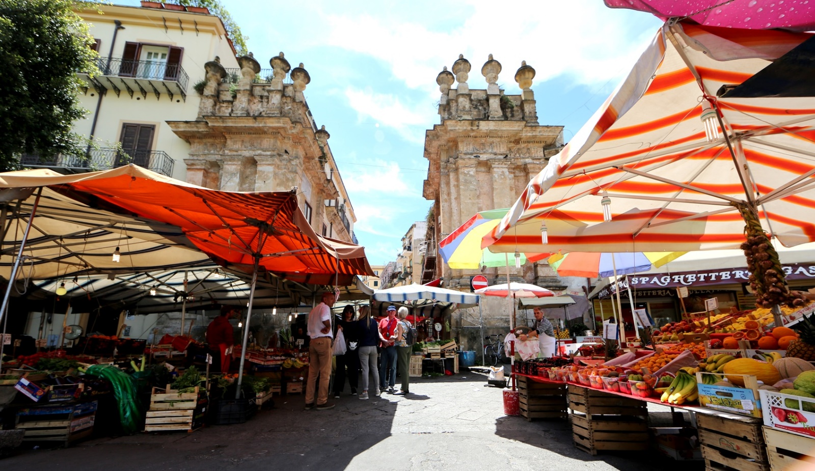

During the tour will be possible to admire the wonderful palaces, churches, and monument of the historical centre evidence of the many dominations suffered by Sicily over the centuries, and at the same time, experience the everyday life of the inhabitants who go shopping, chat with each other and take time for a street food snack

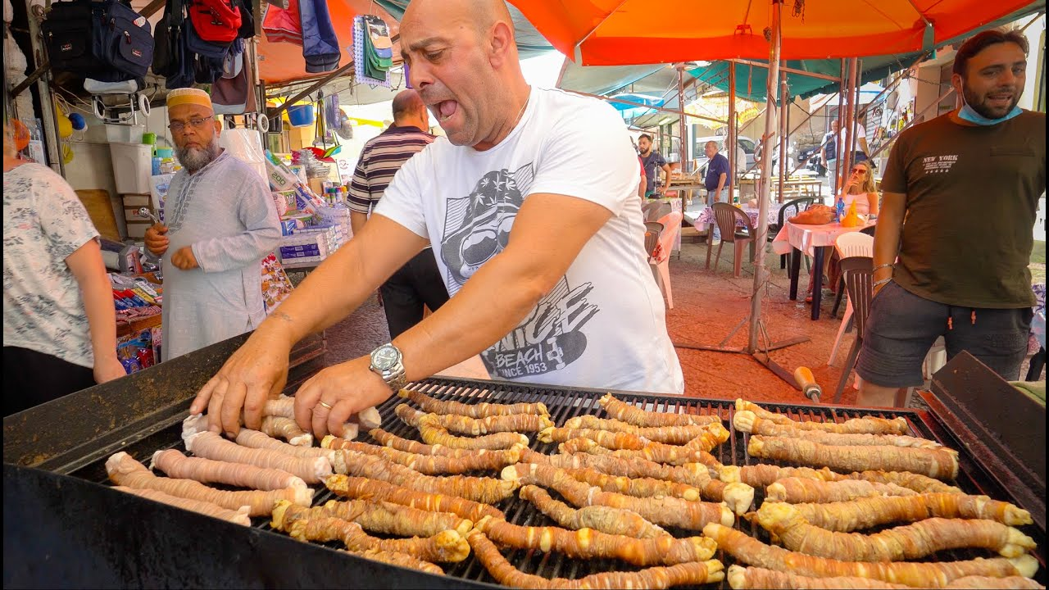

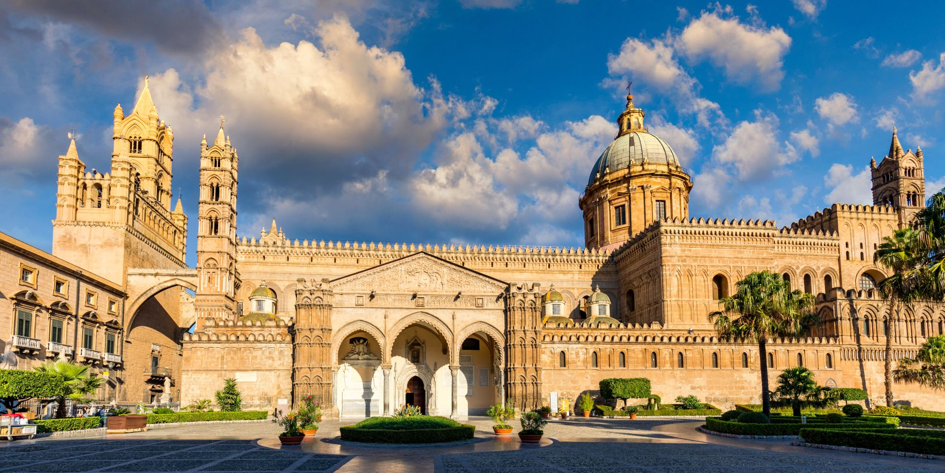

Street food experience.

At the end of the tour, transfer back to the hotel

**Overnight in Palermo**

**3rd day - Cooking class on the Madonie Mountain & Cefalù**

Departure to the Madonie Mountains that are scattered with picturesque hilltop towns. A trip in the old Sicily, travelling among fields, cultivated territory and old timer houses. Arrival in a private farm, meet with a local family, introduction to the regional culinary tyradition and collection of ingredients in the farm garden.

Therefore, cooking lesson in avery familiar atmosphere.

Lunch together to taste the specialities prepared.

After lunch, transfer to Cefalù for a nice walking visit of the village. The town was an ancient fishing village, today a famous tourist center. Set in the medieval district, Cefalù's great tourist attraction is the town's Duomo, a handsome and imposing two-towered Norman cathedral. Begun in 1131, this mighty church dominates the rooftops of the *centro storico*. The building's interior is decorated with lovely mosaics created by twelfth-century Byzantine artists: a large Christ Pantocrator on a gold background dominating the apse, above the Madonna, archangels, and Apostles. These gleaming mosaics are one of Sicily's greatest sights.

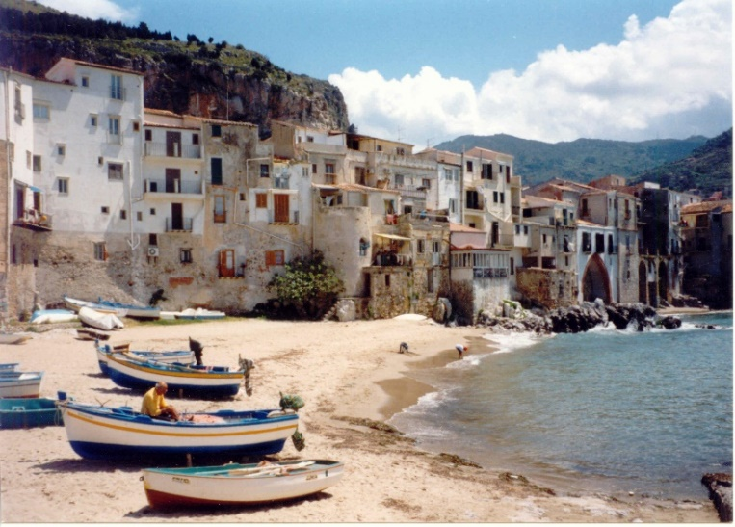

Impressive the sandy beach stretching alongside the town with houses built just on the sand and rocks.

Transfer to the hotel.

**Overnight in Palermo**

**4th day – Palermo – Agrigento - Ragusa**

Departure to Agrigento, upon arrival, meet with the local guide and walking visit at the Temple valley.

Valleys, hills, monuments, and temples, old and ancient, almost all dating back to the time when all civilization finest resided in the Mediterranean, are the traits that have made a city of Agrigento memory. The imposing Doric temples, the agora, the pagan and Christian necropolis and the network of underground aqueducts, are the wealth of a site that covers about 1300 hectares and tells a long history that began in the sixth century. B.C. with the founding of the ancient Greek colony of Akragas and which are now the archaeological heritage of humanity, included in the list of UNESCO since 1997. The Valley of the Temples of Agrigento is still today the most sublime evidence of the Greek civilization in Sicily.

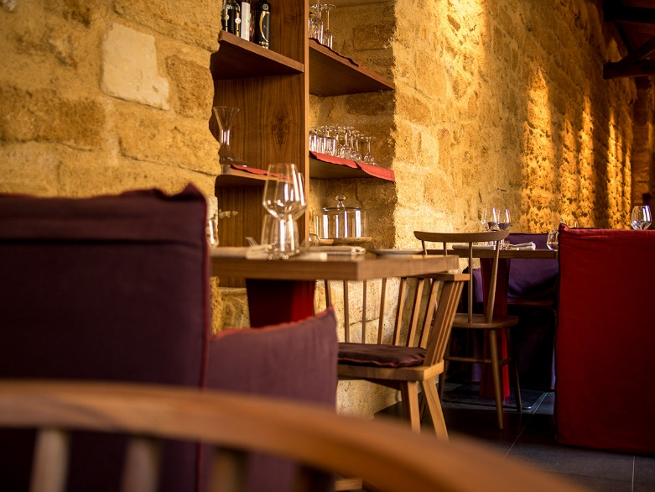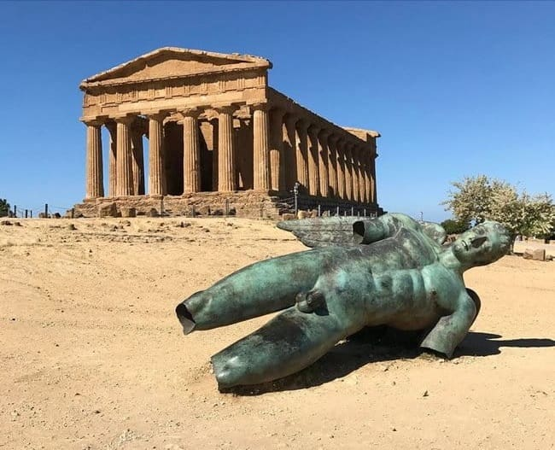

Lunch will be arranged in a gourmet restaurant of good level, that use Km0 ingredients.

In the past, the restaurant, was the sacristy of the adjacent church.

After lunch, transfer to Ragusa.

**Overnight in Ragusa**

**5th day – Ragusa & Scicli**

Departure to Ragusa Ibla, one of the most fascinating towns in Sicily. Essentially Baroque, the Ragusa you will see today dates almost entirely from 1693. Indeed, it was in this year that Ragusa, along with its neighbours, [Noto](http://www.thethinkingtraveller.com/thinksicily/guide-to-sicily/towns-and-cities-in-sicily/noto.aspx), [Modica](http://www.thethinkingtraveller.com/thinksicily/guide-to-sicily/towns-and-cities-in-sicily/modica.aspx), Scicli and [Catania](http://www.thethinkingtraveller.com/thinksicily/guide-to-sicily/towns-and-cities-in-sicily/catania.aspx), was razed to the ground by a terrible earthquake that hit most of the eastern side of Sicily.

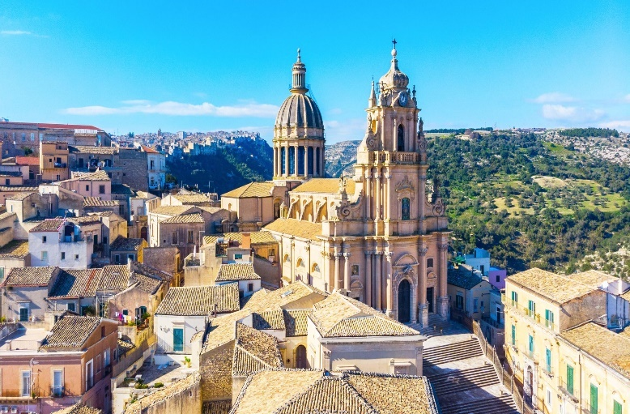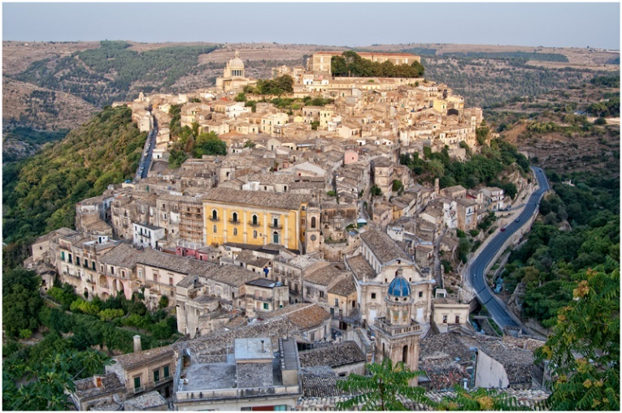Nowadays the town is part of the Val di Noto UNESCO Heritage site and 18 of its buildings are protected by UNESCO patronage.

Lunch will be arranged in a high-level restaurant, located in the hearth of the village. The restaurant is located inside a building partially carved into the rock. Magic atmosphere, sophisticated food, excellent service.

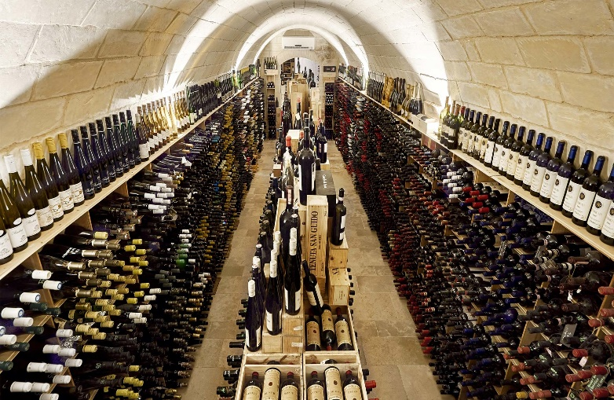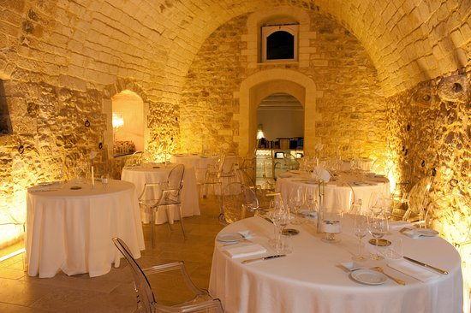

After lunch, transfer to Modica.

A city of Neolithic origin, until the 19th century it was the capital of a county that exerted a vast political, economic and cultural influence. Its historic center is one of the most significant examples of late Baroque architecture.

For its masterpieces, the city was included in 2002, on UNESCO's World Heritage List.

The highest point of the urban center, at 449 meters above sea level, corresponds to the bell tower of the church of San Giovanni Evangelista in Modica Alta, while the municipal seat, in Modica Bassa, is 296 meters above sea level.

Another element that characterizes the area, particularly the countryside, is the dense network of "dry stone walls" that delimit the plots of land.

Modica is also custodian of a 400 years tradition of Sicilian chocolate-making. Being part of the Spanish kingdom for so many years meant that Sicily was often one of the first recipients of the new foodstuffs being brought back from South America. Cacao was one of these and today Modica still specialises in making granulose chocolate, often flavoured with chilli pepper, cinnamon, or vanilla, that is based on Aztec methods and recipes.

Stop in a chocolatier of the village for a chocolate tasting with expresso coffee.

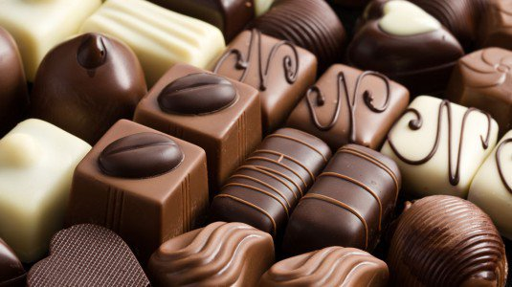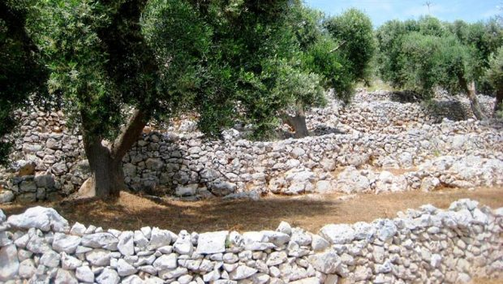

At the end of the tour, transfer to the hotel.

**Overnight in Ragusa**

**6th day – Ragusa – Marzamemi – Noto – Siracusa**

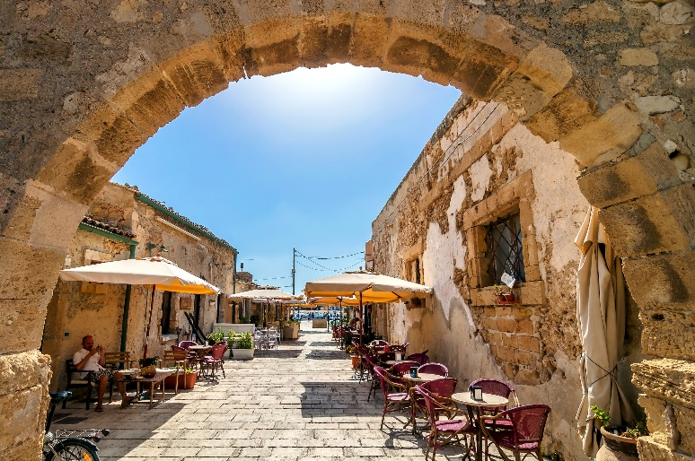Departure to Marzamemian incredible old village, one of the most picturesque villages in Sicily. To those who visit it for the first time it seems to have been catapulted back in time in Arabic period, when life was based essentially on fishing. Crystal clear sea, beaches and history make the village a place to discover and live. Interesting is the small tuna local producer where is also possible to buy tuna in olive oil and other sea food products.

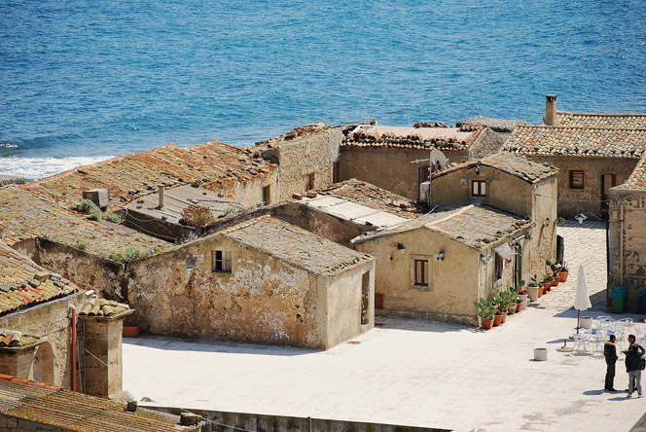

The tour continues to Noto. Upon arrival, wine tasting lunch in the old market “La Loggia”

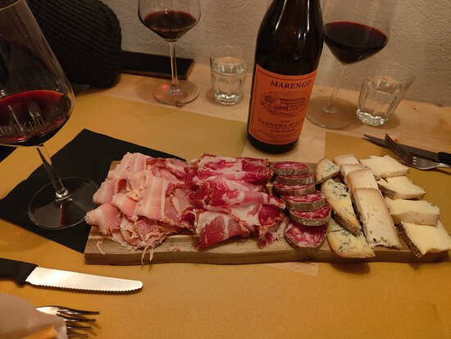Tasting of Val di Noto wine, coupled with local dishes

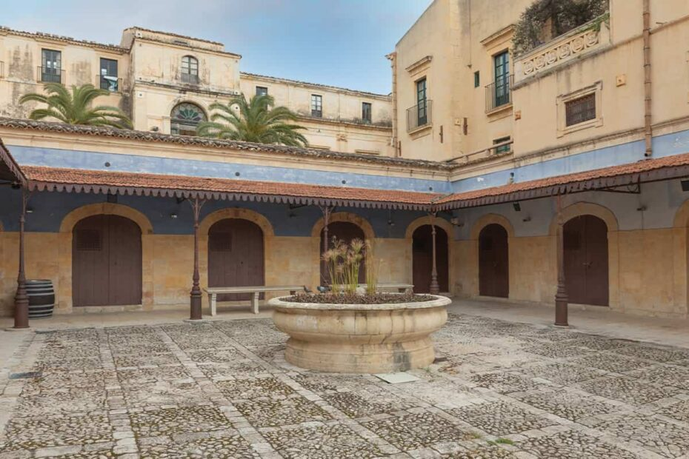

Afterwards the excursion continues towards Noto the most famous baroque town in Sicily. The beauty of Noto’s buildings owes much to the artistic gifts of the local architects and to the skill of local craftsmen (baroque façades). For its beauty, Noto was declared “World Heritage Site”.

Transfer to Siracusa.

Overnight in Siracusa

**7th day – Siracusa**

Full day Siracusa city tour. Visit the archaeological area with the Greek Theatre and Latomie del Paradiso with its famous Ear of Dionysus (a cave with the shape of a tympanum).

Then the city centre of Ortigia Island, primitive cradle of the Greek civilization in Sicily. Walking tour.

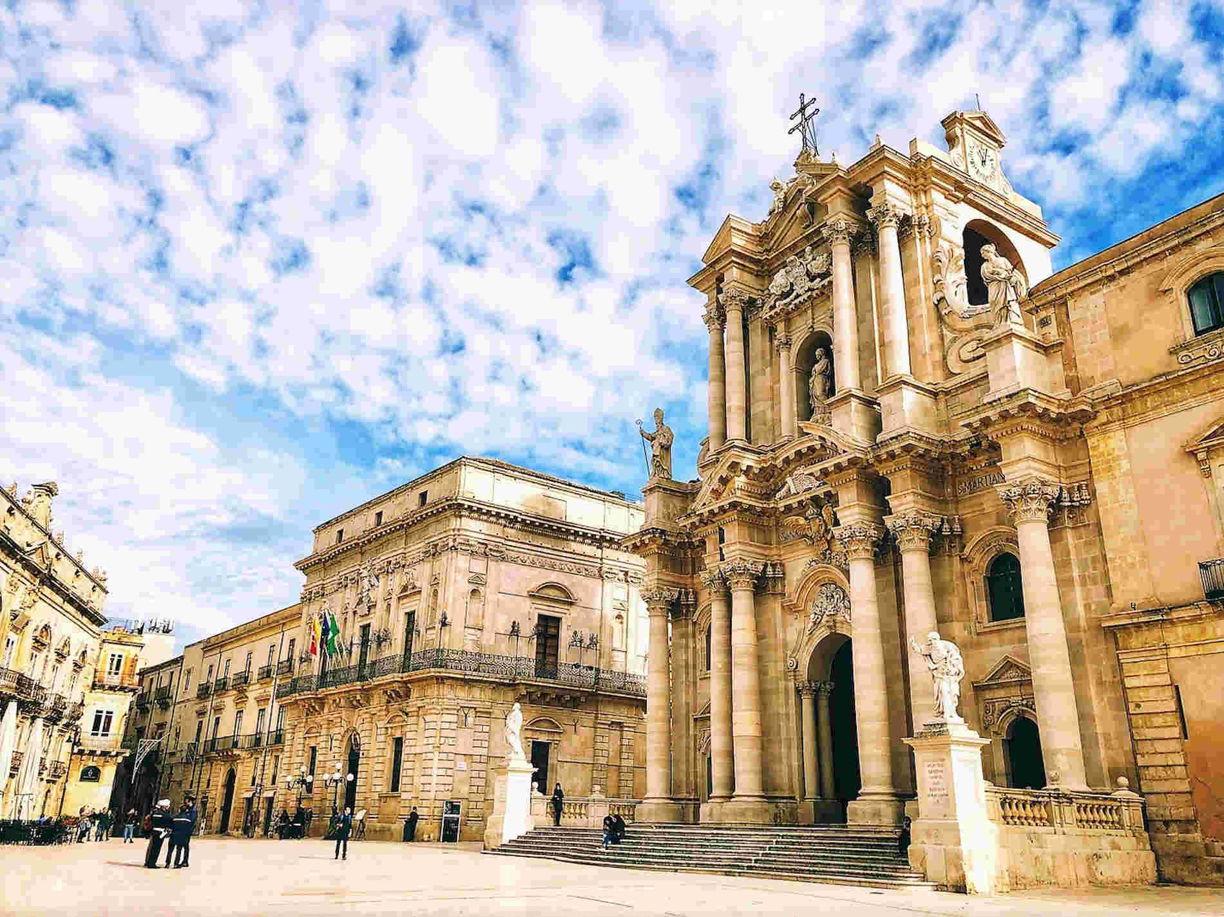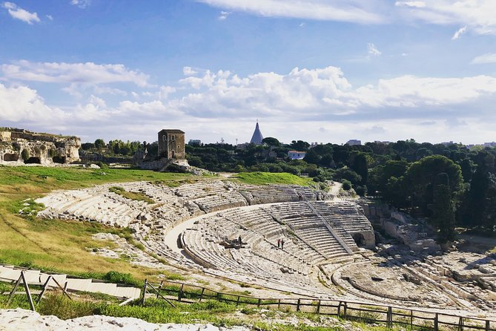

Stop in a **puppet laboratory** to attend curious explanations about the puppets’ tradition in Sicily and how puppets are made.

Lunch in a nice restaurant located in the city centre, an old palace in a typical narrow street.

High level food

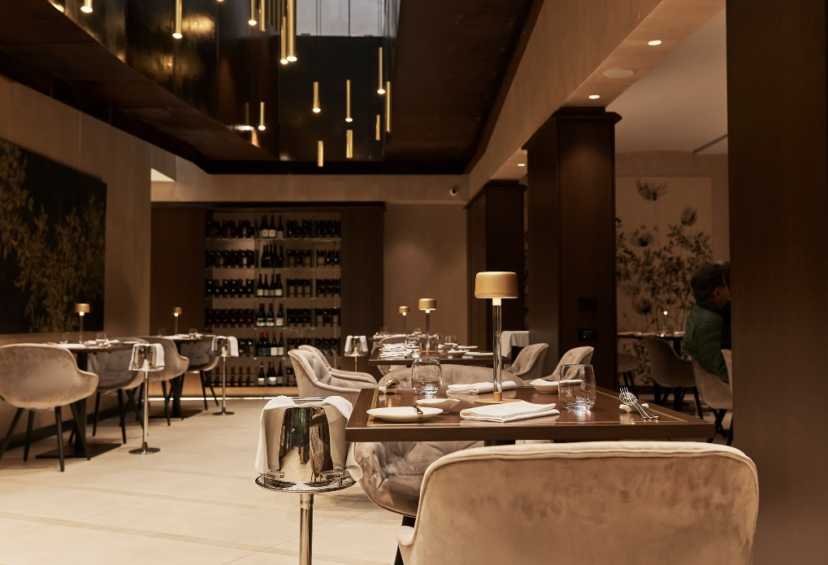

After lunch free time for walking & shopping.

Transfer to the hotel

Overnight in Siracusa

**8th day - Departure from Catania airport**

Transfer to Catania airport for departure.