**Sicily “Soft adventure”**

7 nights / 8days

**PROGRAM**

**1st day - Arrival to Catania transfer to Taormina**

Landing to Catania airport and private transfer to the hotel.

**Overnight in Taormina**

**2nd day – Taormina – Etna North by jeep & quad - Taormina**

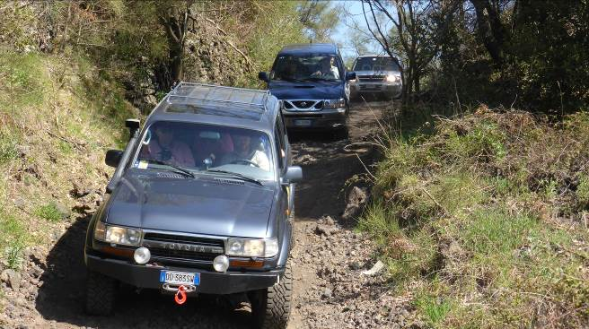Departure by jeep with driver for an amazing adventure along the slopes of Mount Etna North side. This excursion on Etna is a unique experience, full of emotions and guaranteed fun, suitable for everyone. An authentic travel experience to discover craters, volcanic caves and paths that wind through the heart of the Etna undergrowth. This excursion on Etna begins on our 4x4 jeep . Along the route that will take us to the north side of Etna, an expert guide will explain the stories and legends of the Etna villages and the volcano.

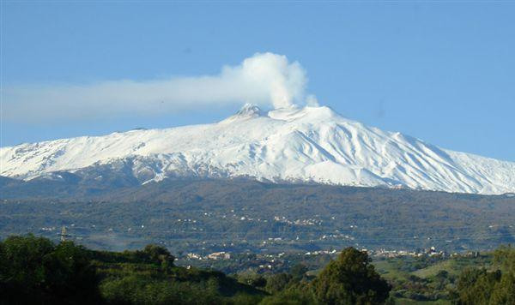

Once in the protected area of the Etna Park, starting of the self-drive quad tour (about 1 hours, with assistance).

After quad tour, stop in a refuge to experience the speciality of the restaurant: maccheroni with meat sauce!

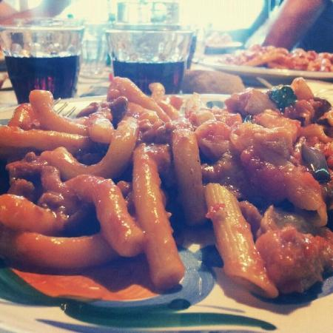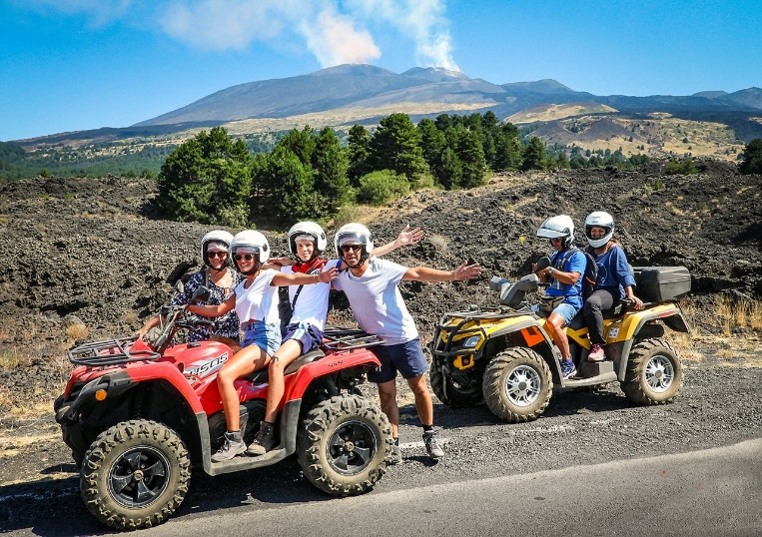

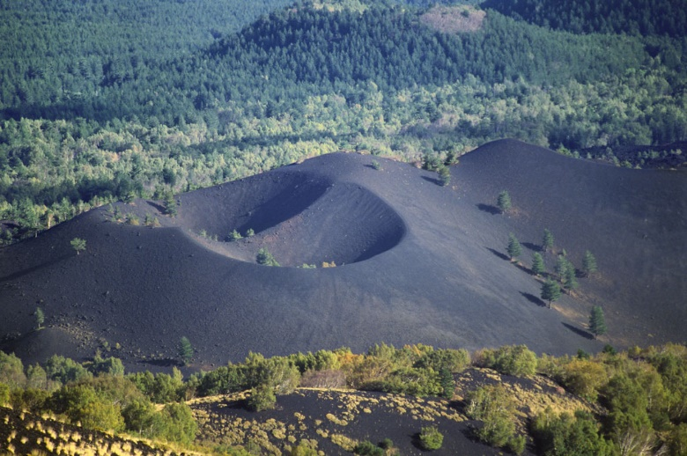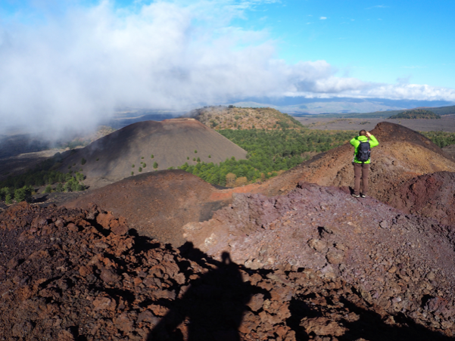After lunch, the excursion continues by hiking along Sartorius Craters (1800mt the highest point that will be reached during this excursion– the total high of Etna is 3.300mt) among Pines, Birches and lava flows, we will discover breath-taking landscapes.

At the end of the activity, return to the hotel.

Dinner free

**Overnight in Taormina**

**3rd day – Taormina & Isolabella boat tour**

Departure for the walking visit of Taormina village: the village has intricated medieval streets and narrow alleys, each with its own secrets, excellent restaurants, cafes and ice-cream parlours. A magnificent view of the sea completes the picture. The most famous is the view of the Greco-Roman amphitheatre, one of the largest in Sicily, with Etna and the sea in the background.

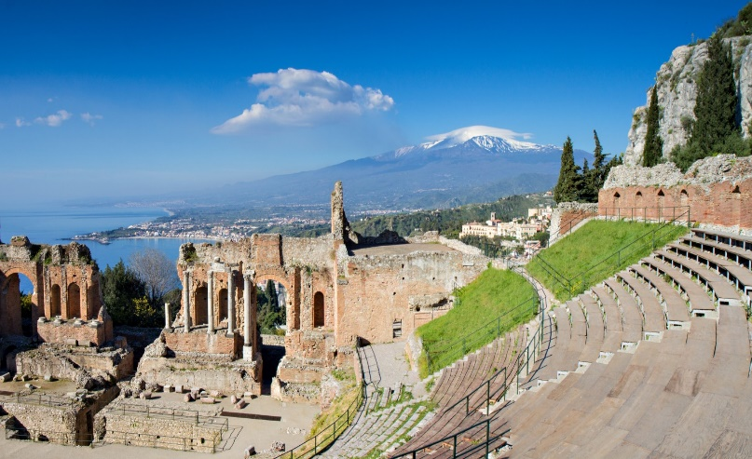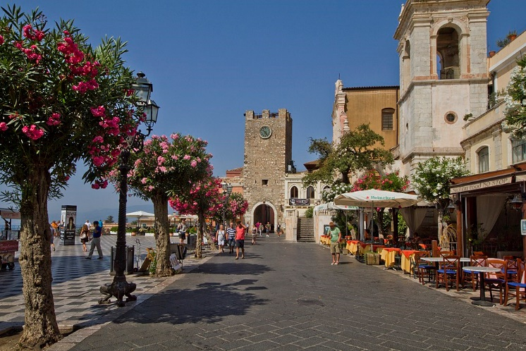

Afterwards, transfer to the most beautiful bay of the coast: Isolabella bay!

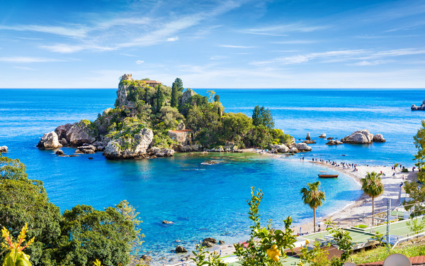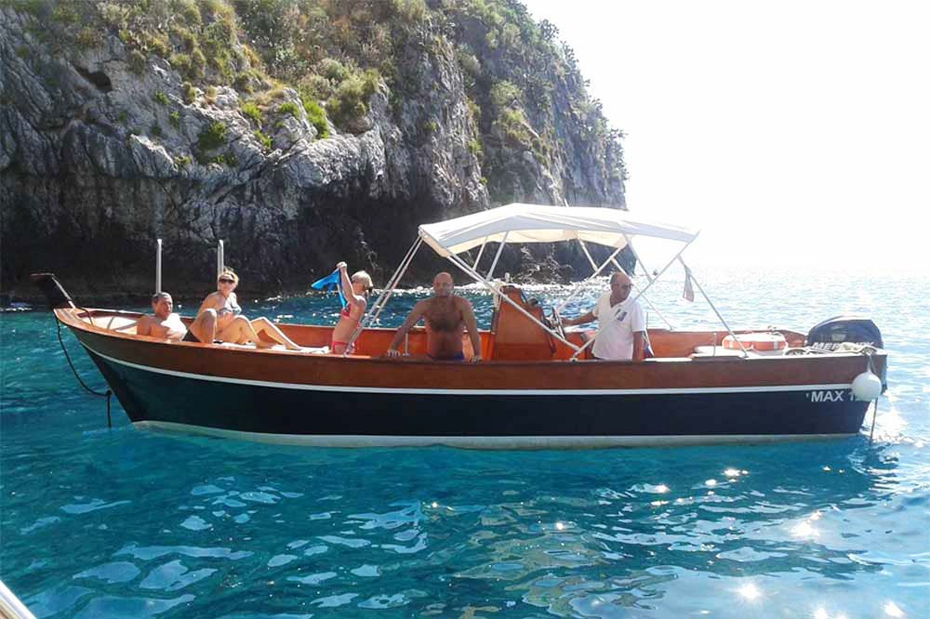

From here, boat tour along the panoramic coast.

Lunch in a trattoria, located right in front the Isolabella island.

After lunch, transfer to the hotel.

**Overnight in Taormina**

**4th day – Taormina – Alcantara river trekking - Taormina**

Departure to Alcantara river: it is the second river in Sicily.

Since the river was dammed in prehistoric times, by the thick lava flow of the Mojo eruption, its abundant and powerful water stream dug the Gorges of Alcantara, a huge and narrow canyon through this obstacle.

Here can be arranged an unusual river trekking and during the activity, the visitors can admire a fantastic and picturesque scenery of wilderness and nature, displaying crystalline waterfalls and ponds hidden between two narrow black walls, amazingly shaped like organ canes

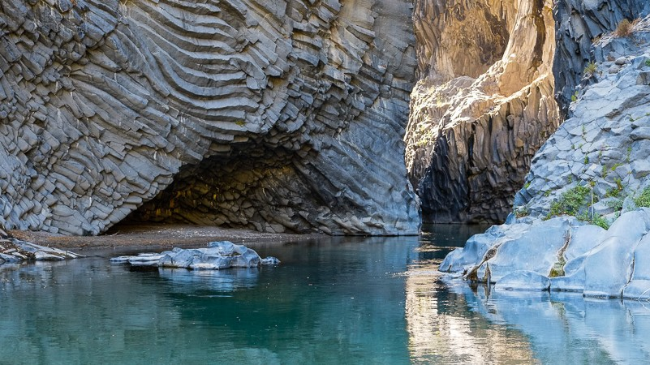

This river trekking is a walking into the cold water of the river. Departure from the panoramic gorges throughout the valley walking for about 2 km into partially deep water, small “natural toboggan” and lakes. The tour takes about 2 hours. Participant will be provided by helmet and water suit and are assisted by professional water trekking guides.

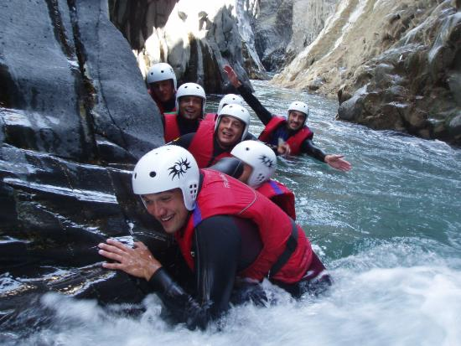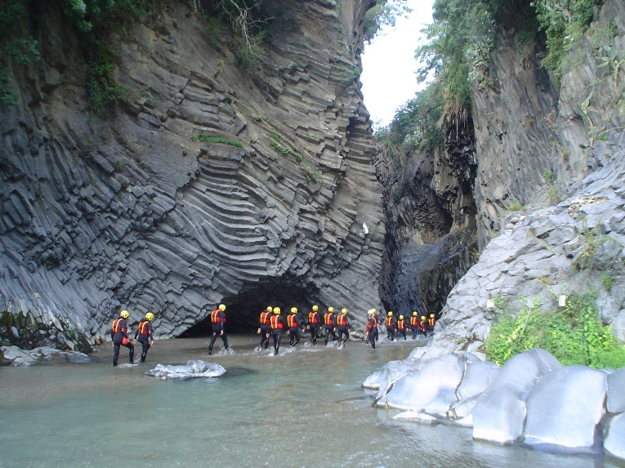

At the end of the activity, transfer in a restaurant located on the seaside, right on the sandy beach, with a panoramic view for the lunch.

After lunch, transfer to the hotel.

**Overnight in Taormina**

**5th day – Taormina – Favara cultural park -Agrigento – Palermo**

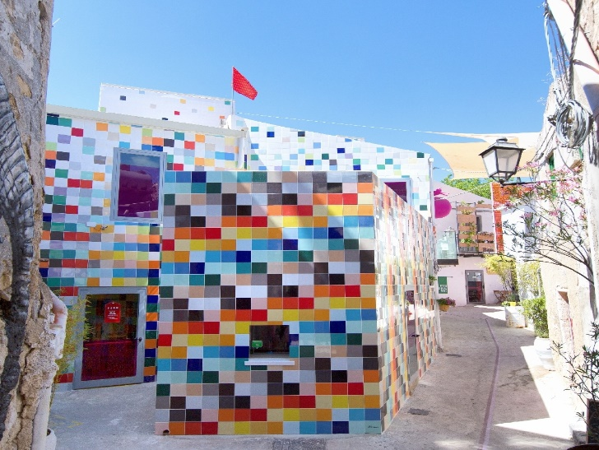Departure to Favara for a unique experience: a walking tour at the Favara Farm Cultural Park. It is one of the most influential independent cultural centres of the contemporary cultural world and one of the liveliest projects of rethinking and rebirth of dying cities.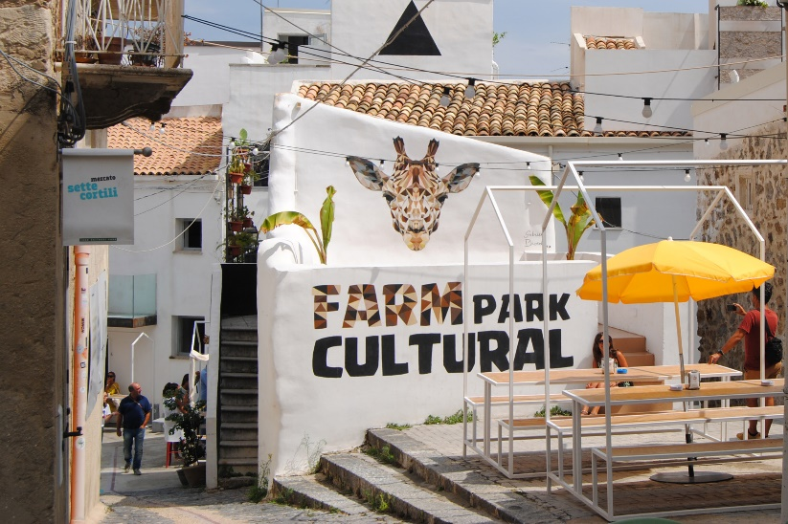

By visiting Farm, you will be prompted to ask yourself who you are, where you are going, to take a stand, to become an actor in trying to change small portions of the world.

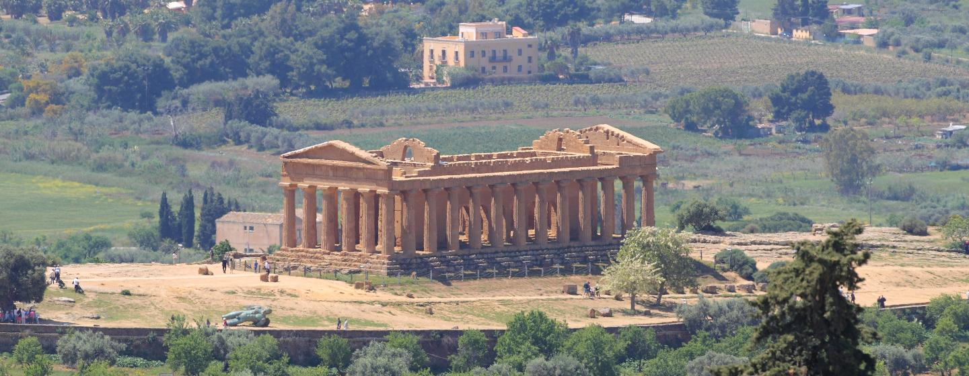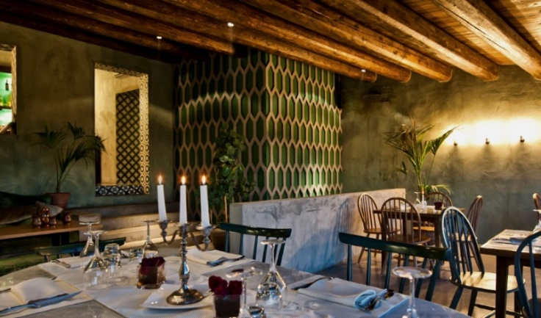After this unusual tour, transfer to Agrigento. Lunch will be arranged in a restaurant of good level, overlooking the temple valley.

After lunch, walking visit at the Temple valley. Valleys, hills, monuments, and temples, old and ancient, almost all dating back to the time when all civilization finest resided in the Mediterranean, are the traits that have made a city of Agrigento memory. The imposing Doric temples, the agora, the pagan and Christian necropolis, and the network of underground aqueducts, are the wealth of a site that covers about 1300 hectares and tells a long history that began in the sixth century. B.C. with the founding of the ancient Greek colony of Akragas and which are now the archaeological heritage of humanity, included in the list of UNESCO since 1997.

The Valley of the Temples of Agrigento is still today the most sublime evidence of the Greek civilization in Sicily.

At the end of the visit, transfer to Palermo

**Overnight in Palermo**

. **6th day – Monreale + Palermo with street food experience**

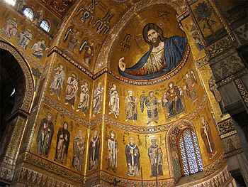Departure to Monreale for a visit to the wonderful Cathedral with its Byzantine mosaics and the adjoining Cloister recognized as the masterpiece of medieval art.

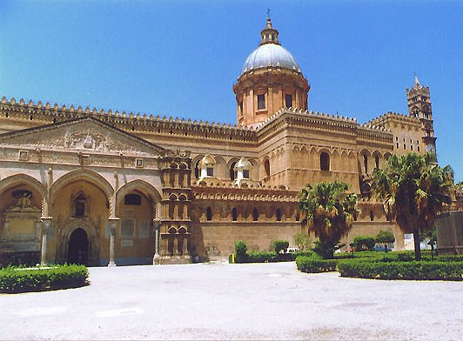

At the end of the visit, transfer to Palermo to continue the tour, visiting the Palazzo dei Normanni and the exterior of the most important buildings located along the main street (Cathedral, Martorana Church, Fontana delle Vergogne).

Lunch will be organized as per a street food tasting.

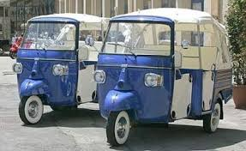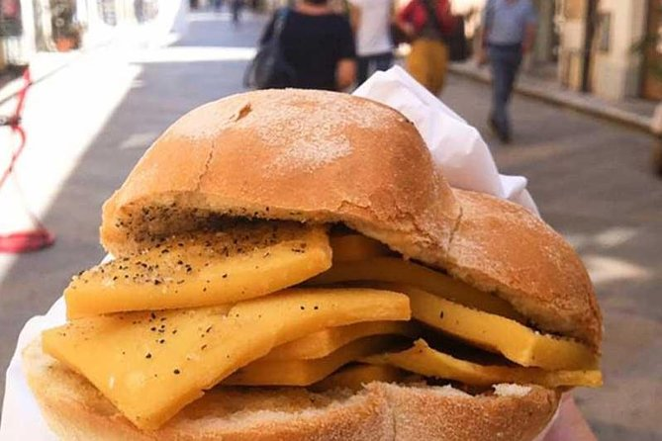After lunch, there will be a funny 3 wheel motorbike tour through the narrow streets of the Arab Quarter (duration about 1 hour, capacity: 3 pax max).

At the end of the tour, transfer back to the hotel

**Overnight in Palermo**

**7th day - Zip line + Cefalù**

Departure to San Mauro Castelverde on the Madonie Park, a Unesco Geopark site. The zip line is 1600 m. long with a drop of 260 m., the starting point is at 925 m. and the arrival point at 669 m., the maximum height of the rope is over 170 m. The maximum speed reached is about 130Km/h. The Madonie Zipline is the only one in Italy to be set at almost 1000 metres and to have as a natural frame in front of it the sea, with a breath-taking panorama.

Single flight: The person must not exceed 120 kg.

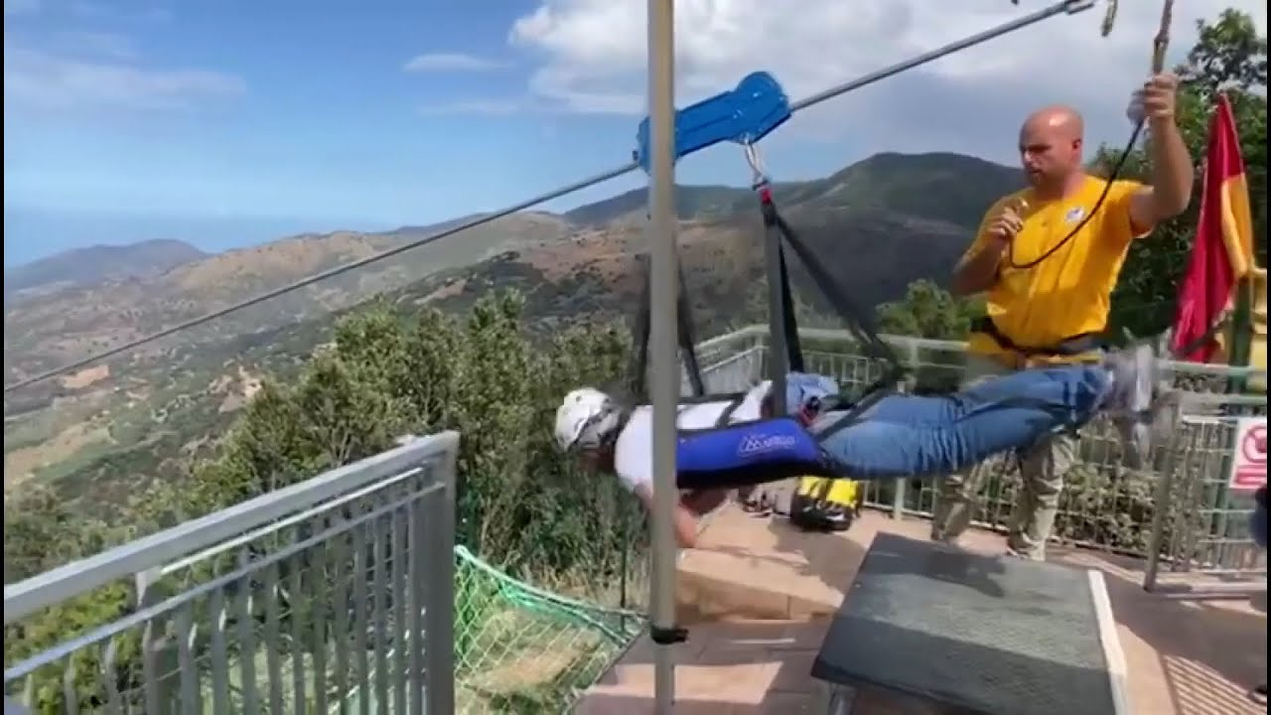Double flight: Two people must not exceed 140 kilograms and the difference in weight between the two people must not exceed 40 kilograms.

After this “adrenaline experience”, the tour continues towards Cefalù : the town was an ancient fishing village, today a famous tourist center. Set in the medieval district, Cefalù's great tourist attraction is the town's Duomo, a handsome and imposing two-towered Norman cathedral. Begun in 1131, this mighty church dominates the rooftops of the *centro storico*. The building's interior is decorated with lovely mosaics created by twelfth-century Byzantine artists: a large Christ Pantocrator on a gold background dominating the apse, above the Madonna, archangels and Apostles. These gleaming mosaics are one of Sicily's greatest sights.

Impressive the sandy beach stretching alongside the town with houses built just on the sand and rocks.

Lunch in a nice restaurant located in the city centre

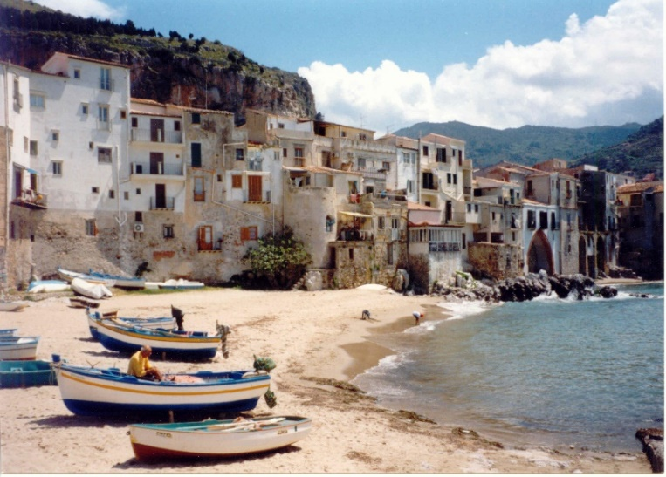

Return to the hotel in the afternoon

**Overnight in Palermo**

**11th day - Departure from Palermo airport**

Transfer to Palermo airport for departure.